Chiropractic Healing & Arts Center: www.reschchiropractic.com
WINTER NEWSLETTER
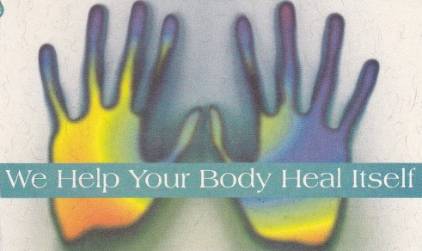

SCIATICA: What is my Sciatic Nerve? The sciatic nerves are the largest and longest nerves of the human body, reaching from the lower back to the tips of your toes. When these nerves are irritated or affected by the inflammation of soft tissue that is often referred to as sciatica. In some people the pain from sciatica can be severe and painful, for others the pain may be infrequent and irritating. Pain is caused when the sciatica nerve roots are irritated, scraped, twisted, stretched or pinched. Sciatica usually only affects one side of the body and the pain often runs through the buttock and/or leg. Sciatica problems can be caused by a few different things: Improper lifting, Cumulative spinal stress, sudden impact or trauma, Falling, Lack of exercise, Over-exertion, Poor posture, Foot or knee problem, or an old injury left uncorrected.
Tips on avoiding sciatic nerve problems involve lifting with your back straight, and bringing yourself up with your hips and legs while holding the object close to your body. Using good posture to relieve pressure on your lower back, avoid sitting for long periods of time, and make sure your workstation is ergonomically correct. Dr. Alan Resch’s approach is to use controlled pressure with the activator to remove the interference from spinal structures. These adjustments can be effective in reducing nerve irritation and associated pain. Schedule your adjustment today by calling 920-465-0101.
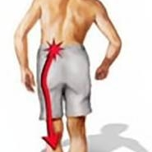
ION CLEANSE: The IonCleanse purifies and detoxes the body more effectively and faster than any herbal or fasting protocols, with little or no stress to the patients. An ionic foot bath is a hydro-therapy device that combines the life-giving properties of water with a specialized bio-electric charge, which enhances and amplifies the body’s ability to heal itself. The energized water helps to re-balance your body’s energy meridians by permeating and realigning an individual’s energy field. Excessive toxins can cause poor nutritional absorption which will, in turn stop the cells from functioning correctly. There are 500,000 different chemicals used to make, clean, coat, wrap and finish the products we use each day. Excessive toxins enter our bodies through the skin, the digestive tract, and the air we breathe.
Do you have rashes, dark circles under the eyes, swollen joints, yellow-green and blotched complexions, colds, flu, sinus problems, lethargy, fatigue, headaches, chronic pain? These signs often indicate a buildup of tissue acid wastes inside the body. Toxins that the body cannot eliminate are stored in fatty tissue, joints, and the brain. These toxins can clog cell membrane walls which are then unable to absorb enough nutrition to support normal cell functioning, over time this leads to weakened immune and lymphatic system. IonCleanse sessions may substantially reduce and even eliminate these conditions.
The IonCleanse is not recommended for people with pacemakers, using a heartbeat regulating device, organ transplant, diabetes, epilepsy, during pregnancy, blood pressure problems, open wounds on the feet, after a recent surgery. We recommend cleansing once per week for 12 weeks. Receive a 40 % discount when you purchase a package of 12 sessions.
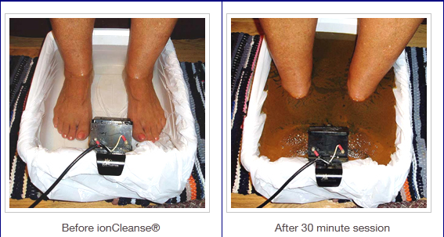

ZYTO COMPASS: Tired of guessing about nutritional supplements? The ZYTO’s technology measures your body’s response to a specific library of nutritional products, asking your body which it prefers. When you place your hand on the hand cradle, stimuli are sent to the body representing each individual product. The software then records your body’s responses whether positive or negative and ranks them. The compass then generates a report showing which nutritional products your body is lacking and needing. You want to invest in supplements that will do you the most good. The compass puts you in touch with your body and helps you make those decisions. So take 20 minutes out of your day and stop guessing about nutritional supplements and schedule your Zyto compass scan today!
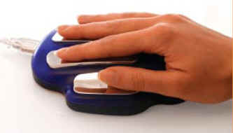

NUTRI-BURN: NEW PRODUCT: AVAILABLE IN VANILLA OR CHOCOLATE
Protein helps build and repair muscle tissue. Nutri-Burn provides essential nutrients to support metabolism while allowing additional energy needs to be met by the body’s fat stores. This product is lactose-free whey protein, calcium caseinate protein, and conjugated linoleic acid; this enhances the buildup of lean muscle mass. The benefits of this great new product are that it promotes lean muscle mass and fat burning, curves appetite for longer, provides 25 grams of lactose-free whey protein per serving, helps boost energy levels, can increase resting metabolic rate, and provides 60% or more of the daily value of 14 essential vitamins and minerals.

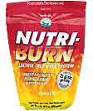
VITAMIN D3: There have been new studies on Vitamin D3, and is to be 800% more effective for children than a flu vaccine:
A clinical trial led by Mitsuyoshi Urashima and conducted by the Division of Molecular Epidemiology in the Department of Pediatrics at the Jikei University School of Medicine Minato-ku in Tokyo found that vitamin D was extremely effective at halting influenza infections in children. The trial appears in the March, 2010 issue of the American Journal of Clinical Nutrition. The results are from a randomized, double-blind, placebo-controlled study involving 334 children, half of which were given 1200 IUs per day of vitamin D3. In other words, this was a “rigorous” scientific study meeting the gold standard of scientific evidence. In the study, while 31 or 167 children in the placebo group contracted influenza over the four month duration of the study, only 18 or 188 children in the vitamin D group did. This means vitamin D was responsible for an absolute reduction of nearly 8%. Flu vaccines, according to the latest scientific evidence, achieve a 1% reduction in influenza symptoms. This means vitamin D appears to be 800% more effective than vaccines at preventing influenza infections in children. Another study that was recently done shows that ¾ of American’s are lacking Vitamin D!
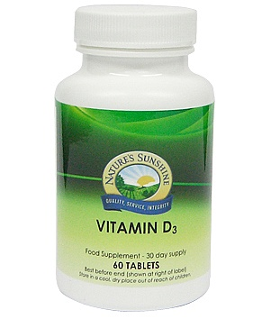

DR. ALAN W. RESCH
1805 ALLOUEZ AVE, STE. 2- GREEN BAY, WI 54311
920-465-0101

